A341-ME-Syro-Hittite-Astarte-Figurine-Terracotta-Late Bronze Age-1500 - 1200 BCE

 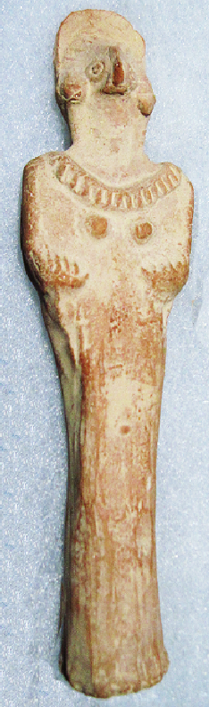 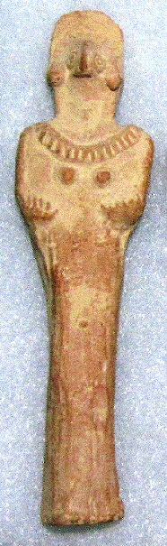 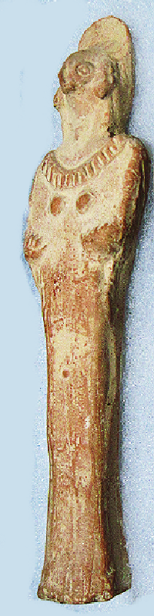

Figs. 1-4. Syro-Hittite-Astarte-Figurine-Terracotta-Late Bronze Age-1500 - 1200 BCE

**Case no.: 3**

**Accession Number: A1341**

**Formal Label**: Syro-Hittite-Astarte-Figurine-Terracotta-Late Bronze Age: 1500 - 1200 BCE

**Display Description:**

This stylized female figurine has a cylindrical body in a dress that extends with slight folds to the base. The face is dominated by a raptorial beak suggestive of the practice of excarnation that takes place with the deceased at the scaffolding of the body. The anthropomorphic features also prevail with circular wire earrings and large circular eyes, which are set off by an elaborate semi-circular hooded coiffure. Two short arms are cupped upwardly under the breasts. A faint, everted navel is located in the lower abdomen area.

**LC Classification:** BL1605 A5

**Date or Time Horizon:** Late Bronze Age-1500 - 1200 BCE

**Geographical Area:** N Syria, S Anatolia.

**Map, GPS coordinates:** N Syria, S Anatolia

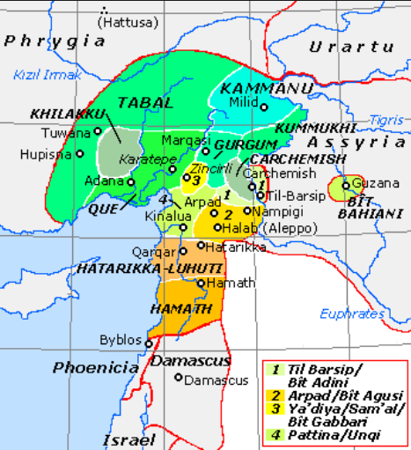

**Fig. 5.** Map of Luwian-, Aramaic- and Phoenician-speaking political entities of the the Syro-Hittite states in northern Syria and southern Anatolia from https://upload.wikimedia.org/wikipedia/commons/f/fe/NeoHittiteStates.gif.

**Cultural Affiliation:** Syro-Hittite

**Medium:** Terracotta

**Dimensions:** H. 13.4 cm., 5 1/4 in

**Weight:**

**Condition: original**

**Provenance:** Ex. Private collection 1980's; Gideon Sasson, Sasson Ancient Art, King David Hotel - Annex, Jerusalem - 94101,  Israel.

**Discussion**:

The cylinder bead necklace mimics the style that was popular at the time (cf. Spycket, A., Borowski Collection, 2000, Cat. no. 84, p. 102, (photograph, p. 101), for the type with long arms; Keel, O., Freiburg, 2008, p. 23, fig 3).

**References:**

Cornelius, Izak. 2004. *The many faces of the goddess: the iconography of the Syro-Palestinian goddesses Anat, Astarte, Qedeshe.* Fribourg, Switzerland: Academic Press; Göttingen: Vandenhoeck & Ruprecht.

Keel, O. 2008. *Gott weiblich: Eine verborgene Seite des biblischen Gottes, Gutersloher Verlagshaus*. Freiburg.

Spycket, A. 2000. *The Human Form Divine. From the Collection of Elie Borowski,* Exh. cat., Jerusalem: Bible Lands Museum.